{{DATE}}

**{{CLIENT_NAME}}**

**{{ADDRESS}}**

**ATTENTION: {{CONTACT_PERSON}}**

Dear Sir/Madam,

We take special pleasure in submitting our firm quotation for the KYOCERA DIGITAL COPIER ECOSYS M4125idn as follows:

**BLACK ‘n WHITE COPY & PRINT, COLORED SCAN**

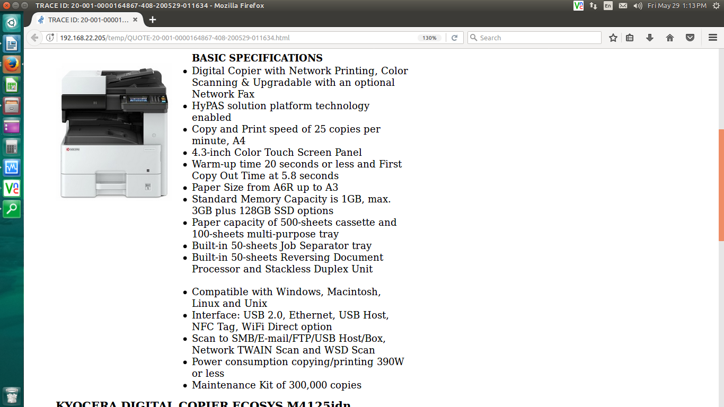

* **PRICE OF MACHINE AND ACCESSORIES (VAT INCLUSIVE)**

|  |  |  |
| --- | --- | --- |
| 1 unit of KYOCERA DIGITAL COPIER ECOSYS M4125idn | Php | **180,000.00** |

**SPECIAL LIMITED PROMO**

MACHINE PRICE: Php 180,000.00

LESS PROMO DISCOUNT Php 61,200.00

**TOTAL DISCOUNTED AMOUNT Php 118,800.00 (Less 10% if COD = Php 106,920.00)**

Php 9,900.00/MO. FOR 12 MONTHS (CREDIT CARD)

**OPTIONAL/ACCESSORIES (NOT INCLUDED IN MACHINE PRICE)**

PAPER CASSETTE PF-471(TWO 500-SHEET) PHP 43,900.00

ADDITIONAL 3 YEARS SERVICE WARRANTY Php 8,400.00

STEEL TABLE/CABINET Php 6,700.00

* **PRICE OF CONSUMABLES (VAT EXCLUSIVE)**

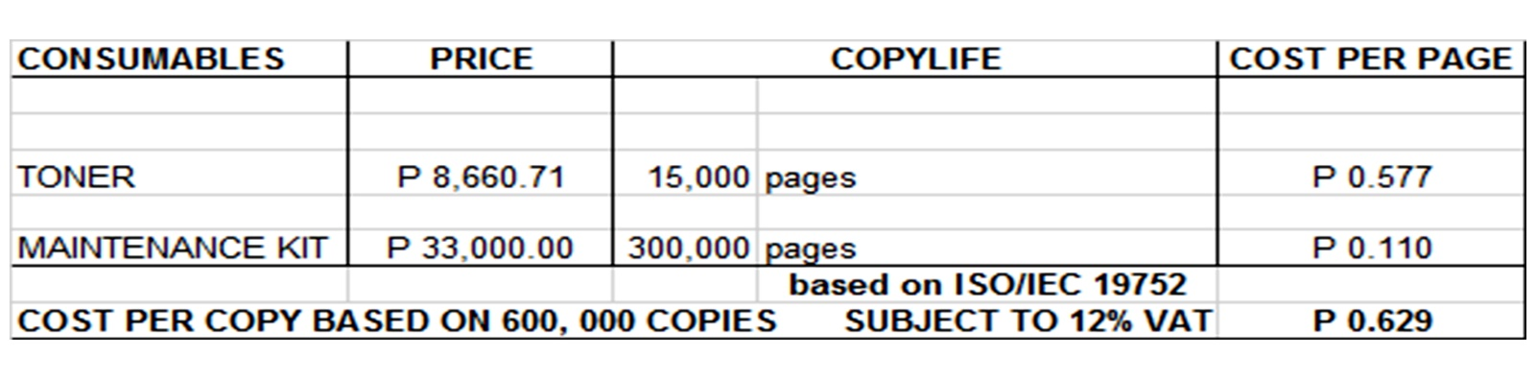

**Terms of Payment:** CASH  
**VALIDITY:** Prices are subject to change without prior notice, please confirm with us prior to finalization of order.  
  
**WARRANTY:**   
  
KYOCERA DIGITAL PLAIN PAPER COPIERS are guaranteed on spare parts replacement FREE OF CHARGE for TWO (2) years, or up to 300,000 copies/print/scan whichever comes first.  
  
Warranty for accessories and options is ONE (1) year from the date of delivery.  
  
We also assure prompt service whenever you need assistance. Repair service is FREE for TWO (2) years.

Installation and Training of Personnel: Our expert service engineers install all our machines and they will be glad to train interested personnel on the detailed mechanics of the machine free of charge.

Moreover, the amount quoted above excludes the cost of any required tests or medical certifications such as, but not limited to Rapid tests, Antigen tests, and RT-PCR tests. The actual cost will be billed separately

We are looking forward to hearing from you soon. For any questions or concerns, please feel free to call us at 0917-624-0820  
  
  
Very truly yours, Conforme:  
  
  
**JAYPEE SONIEL _______________________________________**  
SENIOR ACCOUNT EXECUTIVE II

09176240820 (Viber Ready)